

**Major Project Written Report**

**CHE1617- 135**

**Development of a biobetter for Gaucher Disease**

Name of Student : Lim Junwei Darien

Care Group : D6

Industrial Supervisor : Dr Tan Yun Lei

TP Liaison Officer : Dr Wuang Shy Chyi

Submission Date : 14 Oct 2016

**Diploma in Chemical Engineering**

**AY 2016/2017**

Temasek Polytechnic

School of Applied Science

**Diploma in Chemical Engineering**

### AY 2016/2017

### Subject: Major Project (Level 3)

**Declaration of Originality**

I hereby declare that the work submitted by me is a result of my own effort. I affirm that there is no plagiarism and copying, either partially or entirely, from someone else's designs and works, without giving proper credit and acknowledgement to the source(s)/author(s).

I am aware that I shall be subjected to disciplinary actions deemed appropriate by Temasek Polytechnic, School of Applied Science if I am found to have committed or abetted the offence of plagiarism in relation to this submitted work.

|  |  |  |  |
| --- | --- | --- | --- |
| **Name** | **Admission Number** | **Signature** | **Date** |
| Lim Junwei Darien | 1401552C | Darien | 14 Oct 2016 |

**Acknowledgement**

This internship opportunity from Bioprocessing Technology Institute, A*STAR was a great one. It has allowed me to research on the development of a biobetter for gaucher disease. At the same time, this was also an eye opening experience for me to understand how a research institute operates and carries out their various experiments. I am honoured and thankful to be able to work with researchers and meet inspiring people in this company.

First and foremost, I would like to thank Dr Song Zhi Wei for allowing me to do my internship in his lab.

Secondly, I would like to express my deepest gratitude to my supervisor, Dr Tan Yun Lei. Despite her busy schedules and my limited knowledge in this field, she took time to listen and patiently guided me onto the correct path. This project would not be possible without her.

Furthermore, I would also like to extend my thanks to Dr Lin Pao Chun, who advised me in the absence of my supervisor.

Lastly, I want to thank all my other colleagues, Mr. Chan Kah Fai, Mr. Ryan Haryadi, Mr. Wahyu Shahreel, Mr Rizal Ismail, Dr Natasha Ann Pereira, Ms. Helen Pu for creating an enjoyable working experience and willingly helped me out with their abilities.

This opportunity will be a stepping stone for my future career. I will continue to use the knowledge that I have learnt here and improve it. I hope to work everyone again in future.

**Table of contents**

Acknowledgement III

Abstract VI

1 Introduction 1

1.1 Background Information 1

1.2 Objective & Scope 1

2 Literature review 2

2.1 Gaucher’s Disease 2

2.2 Enzyme Replacement Therapy 3

2.3 Chinese Hamster Ovary Cells 4-5

2.4 Signal Peptide 5

2.5 Linearized Plasmid 5

2.6 Chromatin Positional Effect 5

3 Materials & methods 6

3.1 Cell Culture 6

3.2 Polymerase chain reaction of wild type glucocerebrosidase gene 6

* 1. Polymerase Incomplete Primer Extension (PIPE) 7

3.3.1 Obtaining recombinant plasmid with truncated-signal peptide

Glucocerebrosidase gene 7-9

3.3.2 Obtaining recombinant plasmid with full-signal peptide

Glucocerebrosidase gene 10

3.4 Linearizing Plasmid 11

3.5 DNA Sequencing 12

3.6 Transfection 13

3.7 Selection& Amplification 13

3.8 Qualitative analysis of glucocerebrosidase using western blot 14

3.9 Quantitation analysis of glucocerebrosidase 15

4 Results 16

4.1 Gel electrophoresis of pCID vector and glucocerebrosidase gene after

PCR 16

4.2 DNA sequencing of recombinant plasmid 17

4.2.1 Truncated signal peptide 17-21 4.2.2 Full signal peptide 22

4.3 Linearization of plasmid 22 4.4 Gene amplification with methotrexate 23-24

5 Discussion 25-26

6 Conclusion 27

References 28-30

Appendix 1: Proposal 31-41

Appendix 2: Enzyme Activity Assay after 50nM amplification of adherent cells 42-43

Appendix 3: Enzyme Activity Assay after 200nM amplification of adherent cells 44

Appendix 4:Enzyme Activity Assay after 500nM amplification of adherent cells with different collection dates 45

Appendix 5:Enzyme Activity Assay after recovery from no HT media for suspension

Cells 46

Appendix 6:Enzyme Activity Assay after 50nM amplification for suspension cells 47

**Abstract**

Gaucher disease is a lysosomal storage disorder and enzyme replacement therapy (ERT) is an established treatment for Gaucher disease patients. The recombinant enzyme is intravenously administered and delivered to the lysosomes of macrophage cells through cell-surface mannose receptors. Imiglucerase is the only protein drug expressed in wild-type Chinese Hamster Ovary (CHO) cells, which requires exo-glycosidase treatment to expose core mannose glycan residues that can be recognised by the macrophages. Our CHO-gmt4D cell line allows the production of mannose-terminated N-glycosylated proteins directly from CHO cell culture. The aim of this study was to develop CHO-gmt4D cells that express high yields of glucocerebrosidase with mannose-terminated N-glycans.

We have tested two recombinant plasmids that expressed the glucocerebrosidase enzyme with either a full-length signal peptide or a truncated signal peptide in the CHO-gmt4D cell line. We have also tested different plasmid conformation during transfection. This CHO-gmt4D cell line also has a defective dihydrofolate reductase (DHFR) gene, allowing for gene selection and amplification. Methotrexate (MTX) was used to amplify glucocerebrosidase production in pools, as quantified by an enzyme activity assay and by Western blot analysis.

Results have shown that higher concentration of recombinant enzyme was produced in the cell line harbouring the plasmid encoding for the full-length signal peptide compared to the one encoding for shorter signal peptide. In addition, amplification also had showed promising results, all the adherent cell pools had increase of protein expression levels.

It can be concluded that using the DHFR system can greatly increase glucocerebrosidase expression levels through amplification, and that linearizing the plasmid, modifying the native signal peptide does not affect the protein expression level greatly in CHO-gmt4D cell. Future studies should be conducted on overcoming the chromatin positional effects as well as to test on different non-native signal peptides combination to improve protein expression levels.

1. **Introduction**
   1. **Background Information**

Gaucher Disease is the most common lysosomal storage disorder (LSD) in the world that happens to 1 in 57000 people. [1, 2] There are different approaches in treating this disease and enzyme replacement therapy (ERT) is one of them. [1] Patients suffering from Gaucher Disease inherit a mutated form of the enzyme glucocerebrosidase. Therefore, they require frequent infusions of the recombinant wild type enzyme to maintain normal lysosomal function, restoring patients’ health. Recombinant glucocerebrosidase is taken up through mannose receptors on affected macrophage cells. As such, mannose-terminated glycans on recombinant glucocerebrosidase is necessary for efficient uptake into macrophages. [2] In the current market, imiglucerase or Cerezyme® is the only protein drug that is expressed in wild type Chinese Hamster Ovary (CHO) cells, which requires exo-glucosidase treatment to expose core mannose. The other biosimilars are expressed in carrot cells (taliglucerase alfa) and human cells (Velaglucerase alfa). [4] The problem now is that they can cost up to US$642,900 a year to treat one patient. [5]

1. **Objective & Scope**

There have been no studies conducted on glucocerebrosidase that is expressed in Chinese Hamster Ovary (CHO) cells that have a modified glycosylation process. Hence, the aim of this report was to use the DHFR system, modification of the native signal peptide and plasmid conformation, to obtain cells that have very high levels of glucocerebrosidase expression to fulfil the market needs in CHO cells that have a modified glycosylation process. This allows the production of predominantly mannose-terminated glycans in a single step. Thereby producing a biobetter that has greater efficacy and functionality over the existing drugs, while reducing cost to patients.

1. **Literature Review**
2. **Gaucher’s Disease**

Lysosomal Storage Diseases(LSDs) are caused by “specific mutations in genes encoding lysosomal enzymes”, which in turn prevent the degradation of their specific substrates, which include a wide variety of glycolipids, oligosaccharides and glycoproteins. There are more than 50 distinct lysosomal storage diseases, with most being inheritable autosomal recessive diseases. [2]

Gaucher Disease being one of the LSDs that is caused by the mutation of the glucosylceramidase beta(GBA) gene, is characterised by the accumulation of the glycolipid substrate glucosylceramide in lysosomes of macrophage cells. [3,6] There are three types of Gaucher Disease, with type I being the most common in patients. Some of the symptoms include enlarged liver and/or spleen, low blood platelet count, anaemia and low white blood cell count. Patients with type II and III Gaucher Disease also suffer extensive neurological symptoms, and often do not survive past early adulthood. At present, only type I Gaucher Disease can be treated by Enzyme Replacement Therapy. [6].

1. **Enzyme Replacement Therapy**

Enzyme Replacement Therapy (ERT) is the replacement of a mutated lysosomal enzyme by a recombinant wild type enzyme that will be taken into macrophages intravenously. Glucocerebrosidase is taken in through mannose receptors on macrophage cells. As such, the glycans on recombinant glucocerebrosidase have to be mannose-terminated for efficient uptake. [2]

The first drug approved by the United States Food and Drug Administration (FDA) for Gaucher Disease was Cerezyme® in 1994 [7]. Cerezyme® is expressed in wild type CHO cells, producing a heterogeneous population of glycans on the recombinant enzyme. A second step is required to modify the glycans on glucocerebrosidase to predominantly mannose-terminated forms. [1] In 2009, there was a virus contamination in the Cerezyme® manufacturing plant and it greatly affected the overall drug supply for Gaucher’s Disease. [8] This incident catalysed the FDA approval of biosimilars velaglucerase alfa in 2010 [9] and taliglucerase alfa in 2012. [10] Since Gaucher’s Disease is a rare disease, the treatment can cost up to US$642,900 annually. [5]

**2.3 Chinese Hamster Ovary Cells**

Chinese Hamster Ovary (CHO) cells are excellent for the expression of proteins and they are most commonly used for the mass production of recombinant protein products due to their capacity for single cell suspension culture. They can be genetically modified as well, for example, the knockout of genes can be performed with relative ease. [10] Furthermore, up to 70% of recombinant protein therapeutics are produced using CHO cells. One of the compelling reason is they have similar properties and post-translational modifications compared to that of native human proteins, which greatly decreases the likelihood of rejection when administered to patients. Thus, CHO cell lines are important in bioprocessing research and the manufacturing of therapeutic biopharmaceuticals by increasing protein productivity and reducing safety concerns. [11]

“Glycosylation, the process of attaching sugar moieties to proteins, is a post-translational modification that provides great proteomic diversity. Glycosylation is important for many biological processes which includes cell attachment to the extracellular matrix and protein-ligand interactions in the cell endogenously.” [12] Glycosylation of recombinant protein drugs may also enhance drug efficacy and longevity. [11] In particular, modification of glycans on recombinant glucocerebrosidase is vital for its uptake into macrophages through the mannose receptors. CHO-gmt4, developed by the Song lab, is a mutant that has lost the gene N-acetylglucosaminyltransferase I (GnT1). This cell line was selected using Ricinus communis agglutinin-1 (RCA1) treatment. This mutant produces protein with mannose 5-terminated N-glycans, allowing us to bypass the second enzymatic deglycosylation step required in the production of Cerezyme. CHO-gmt4D is a mutant that has lost GnT1 and the dihydrofolate reductase (DHFR) gene. DHFR was knocked out by the Song lab using a zinc finger nuclease, allowing us to select for and amplify the expression of glucocerebrosidase. [13] By using the DHFR system, DHFR-deficient cells are cultured in high level methotrexate (MTX) as MTX inhibits the DHFR activity in cells. The cells have to amplify the copy number of DHFR locus to survive, and during the process the glucocerebrosidase gene is also co-amplified increasing the chances of having highly producing strain. [11]

**2.4 Signal Peptide**

Signal peptides are chains of 15 to 30 amino acid residues that are responsible for translocation of the protein into the endoplasmic reticulum through the interaction of signal recognition particle (SRP), SRP receptor and the translocon. [14,15,16] The endogenous signal peptide plays a role in regulating the secretion level of the protein in the cell, thus, modifying the signal peptide of the protein can also improve the level of expression of the protein. [16,17] However, some signal peptides only work on specific protein while others are able to promote protein secretion on a variety of proteins. [14] In addition, using native signal peptide is a logical choice apparently but truncation of the peptide can also be considered. [14]

**2.5 Linearizing plasmid**

Most of the time, circular plasmids are used in transfection of DNA into mammalian cells. However, some studies have found that linearizing the plasmid before transfection can increase both the efficiency of stable clone and transgene expression. [18,19] Linearizing of the plasmid using a random restriction cut can cause the gene of resistance gene or the gene of interest to be destroyed. Whereas, using a particular restriction enzyme to cut at non-coding area can retain all important gene elements in the plasmid. [18]

**2.6 Chromatin Positional Effect**

Even with all the ways to increase protein expression levels and obtaining stable clones mentioned above, during transfection the plasmid DNA integrates in a random manner into the cell’s genome. The site of integration can impact the transcriptional activity of the gene and this is known as chromatin positional effects. Thus expression levels can vary between individual clones. “Screening of large number of clones will be needed to find efficient and stable clones.” [20]

1. **Materials and Methods**
   1. **Cell Culture**

The CHO-gmt4D glycosylation mutant cells used in this project was provided by Dr Tan Yun Lei. Adherent CHO-gmt4D cells were cultured in Dulbecco’s modified eagle media (DMEM) + Glutamax™ (Life Technologies) with 10% fetal bovine serum (FBS) and Hypoxanthine-Thymidine (HT) supplement (Life Technologies). Adherent cells were grown at 37°C in a humidified incubator with 5% CO2. Suspension CHO-gmt4D cells were cultured in a 1:1 mixture of HyClone™ (GE, USA) and CD-CHO (Life Technologies) media supplemented with HT, 6 mM L-glutamine and 0.05% pluronic acid. Cells were grown at 37°C and 115 rpm in a humidified incubator with 8% CO2.

* 1. **Polymerase chain reaction of wild type glucocerebrosidase gene**

The truncated glucocerebrosidase gene was provided by Dr Tan Yun Lei. The gene amplicon was obtained using polymerase chain reaction (PCR) with Pfx DNA polymerase (Invitrogen, USA).

Forward primer with Kozak sequence (Highlighted):

5’ GCCGCTAGCGCCACCATGGCTGGCAG 3’

Reverse primer:

5’ CGAGCGGCCGCTCACTGGCGACGCCACAG 3’

Followed by the purification of the gene amplicon using GeneJET PCR Purification Kit (Thermo Scientific, USA)

* 1. **Polymerase Incomplete Primer Extension (PIPE) Cloning**
     1. **Obtaining recombinant plasmid with truncated-signal peptide**

**Glucocerebrosidase gene**

Primers were designed according to the selected sequence in the pCID vector (provided by Dr Tan Yun Lei) and truncated-signal peptide glucocerebrosidase gene.

Forward Primer for pCID vector:

5’ CCTACCTGTGGCGTCGCCAGTGATGGCGGCCGCTCGAGTCTAGAC 3’

Reverse Primer for pCID vector:

5’GAGGCTGCCAGCCATGGTGGCCTGTGCTGGATATCTGCAGAATTCCACC 3’

Forward Primer for truncated signal peptide glucocerebrosidase gene:

5’ GGTGGAATTCTGCAGATATCCAGCACAGGCCACCATGGCTGGCAGCC 3’

Reverse Primer for truncated signal peptide glucocerebrosidase gene:

5’ GTCTAGACTCGAGCGGCCGCCATCACTGGCGACGCCACAGGTAGG 3’

DNA templates went through PCR using Pfu Turbo DNA polymerase (Agilent,USA). Primers were used with its respective DNA templates in the PCR reaction, with the following components and cycling information:

**Components Volume**

DNA Template Able to give 100 ng of DNA

Primer- Forward (10µM) 1.5 µL

Primer- Reverse (10µM) 1.5 µL

dNTPs (10µM) 1 µL

10x Buffer 1.5 µL

Pfu Turbo 1 µL

Water to 50 µL

**Cycle information**

No. of cycles for all reactions: 34

For vector pCID:

Denaturation: 95°C for 30 seconds

Annealing: 55°C for 1 min

Extension: 72°C for 8 min

For truncated signal peptide glucocerebrosidase gene:

Denaturation: 95°C for 30 seconds

Annealing: 53.5°C for 1 min

Extension: 72°C for 8 min

Subsequently, the PCR products were analysed by running 1% agarose gel electrophoresis at 110V for 30 min. PCR products were digested with Dpn1 (Agilent Technologies, USA) at 37°C for 2 h. 5 µL of each digested pCID vector and truncated-glucocerebrosidase gene sequence was mixed and incubated at 28°C for 2 h to get the recombinant plasmid. The recombinant plasmid was transformed using One Shot TOP10*™* bacterial cells (Invitrogen, USA). The cells were then cultured overnight at 37°C on agar plates that consist of ampicillin (100 µg/mL). Positive colonies were inoculated into 1.5 mL of LB Broth with ampicillin (100 µg/mL) and incubated overnight at 37°C. The recombinant plasmid was extracted using QIAprep® Spin Miniprep Kit (Qiagen,USA).

* + 1. **Obtaining recombinant plasmid with full-signal peptide**

**Glucocerebrosidase gene**

Primer was designed according to the sequence in the recombinant plasmid with truncated-signal peptide glucocerebrosidase gene.

Forward Primer for full-signal peptide glucocerebrosidase gene:

5’GATGCTTACCCTACTCAAAGGCTTGGGACATTCCTCTCTGGAAGGACTTGAAAACTCCATGGTGGCCTGTGCTGGATATCTGCAG 3’

Reverse Primer for full-signal peptide glucocerebrosidase gene:

5’ATGGAGTTTTCAAGTCCTTCCAGAGAGGAATGTCCCAAGCCTTTGAGTAGGGTAAGCATC ATGGCTGGCAGCCTCACAGGATTGC 3’

Primers mentioned above were used in the same PCR reaction as the others. The cycling information was adapted from the truncated glucocerebrosidase gene, except that the extension time had to be changed to 9 min.

The recombinant plasmid was digested with Dpn1 (Agilent Technologies, USA) at 37 °C for 2 h. The recombinant plasmid was transformed using One Shot TOP10*™* bacterial cells (Invitrogen, USA). The cells were then cultured overnight at 37°C on agar plates that consist of ampicillin (100 µg/mL). Positive colonies were inoculated into 1.5 mL of LB Broth with ampicillin (100 µg/mL) and incubated overnight at 37°C. The recombinant plasmid was extracted using QIAprep® Spin Miniprep Kit (Qiagen,USA).

.

* 1. **Linearizing Plasmid**

Recombinant plasmids were linearized by digesting with ASCI restriction enzyme. 30 µg of DNA was added into a 1.5 mL microtube. 15 µL of ASCI restriction enzyme and 11.25 µL of CutSmart buffer were added (New England Biolabs,USA)into the same 1.5 mL microtube. 11.25 µL of water was topped up into the microtube. The mixture was incubated at 37°C for 2 h. The recombinant plasmids were analysed by running 1% agarose gel electrophoresis at 110v for 30 min. The agarose gel was viewed under ultraviolet light and the band size between 5000bp and 4000bp by referring to 1kb DNA ladder (1st BASE, Singapore) was excised out and put into a 1.5 mL microtube. 11.3 µL of 3M sodium acetate (sterile) was added into the microtube. 310 µL of ice cold 100% ethanol (sterile) was added into the microtube. The microtube was incubated at -20°C for 30 min and subsequently spun at 14800 rpm, 4°C for 10 min. Supernatant was removed by not disturbing the pellet. The pellet was washed with 500 µL of 70% ethanol. The tube was again spun at 14800 rpm at 4°C for 5 min. Supernatant was removed by not disturbing the pellet and left to air dry. The pellet was resuspended by adding double-distilled water.

* 1. **DNA sequencing**

10µL of 10-40(ng/µL) purified plasmids and 5 µL of 10-20µM primers were sent to 1st Base for DNA sequencing. Results received from 1st Base were analysed using the BioEdit software [21] and aligned using MultAlin [22].

CMV-F Primer can be found on 1st Base website:

5’CGCAAATGGGCGGTAGGCGTG 3’

Internal Primer:

5’GTTACAGTTCTGGGCAGTGAC 3’

End of gene Primer:

5’CTCACCTGGCTACTCCATTCAC 3’

End of IRES Primer:

5’CGATGATAAGCTTGCCACAACC 3’

End of XhoI Primer:

5’ CGAAAAGTGCCACCTGACGTC 3’

**3.6 Transfection**

CHO-gmt4D cells were counted using Vi-CELL™XR (Beckman Coulter, USA). The volume for 10 million CHO cells was aliquoted and transferred to a 50 mL tube. The tube was centrifuged at 1050 rpm for 5min. The supernatant was aspirated. The cell pellet was washed with 30 mL of Dulbecco's phosphate-buffered saline (Life Technologies), centrifuged at 1050 rpm for 5 min and the supernatant was aspirated (For adherent cells only). The cell pellet was resuspended in 4D Nucleofector™ Solution (Lonza, USA) at room temperature. 5µg of recombinant plasmid encoding glucocerebrosidase and DHFR was added to the solution. Subsequently, the solution was transferred into the Nucleocuvette™ Vessels(Lonza,USA). The vessel was placed into the retainer of 4D-Nucleofector™ Core unit (Lonza, USA) run with the selected CHO-K1 protocol on the machine. The cuvette was left at room temperature for 10 min. Adherent cells were transferred into T75 flask in 10 mL of normal culture medium and cultured at the same condition (stated in section 3.1). Suspension cells were seeded into a 6 –well plate with 2ml of normal culture medium. Suspension cells were cultured in a humidified incubator at 37°C and 5% CO2 for 2-3 days.

* 1. **Selection and Amplification**

Transfected CHO-gmt4D cells were cultured in no HT supplement culture medium until it recovered in 20 mL of the medium in T150 flask for adherent cells and 12 mL of the medium in T25 flask for suspension cells. After the cells recovered from no HT supplement culture medium, multiple rounds of amplification were done using methotrexate (MTX). Concentration of MTX in no HT supplement culture medium was increased after each recovery phase of the cells in this order 50, 200, 500 µM. The cells were cultured in 20 mL and 12 mL of culture medium with MTX in the same condition for both adherent and suspension cells respectively. Cells were banked down in 1mL of 10% DMSO in no HT culture medium and kept in -80°C after each round of amplification.

**3.8 Qualitative analysis of glucocerebrosidase using western blot**

Supernatant of cell culture was mixed with PierceTM Lane marking reducing sample buffer 5x (Thermo Scientific, USA) and incubated at 95°C for 5 min. After incubation, the supernatant was loaded into 4-12% Bis-Tris gel (Life Technologies). Gel Electrophoresis was performed at 30V for 10 min and subsequently 150V for 1 h in a gel electrophoresis tank filled with 1x NuPAGE® MES SDS running buffer. The proteins were transferred to a polyvinylidene difluoride (PVDF) membrane using iBlot™ 2 (Invitrogen, USA) at 20V for 7 min. Blocking of the membrane was done using 5% non-fat milk in phosphate-buffered saline with 0.1% tween(PBST) for 1 h. The membrane was incubated with the primary rabbit polyclonal anti-glucocerebrosidase antibody (Sigma-Aldrich, G4171) at a dilution of 1:1000 in PBST with 1% milk for 2 h at room temperature. The membrane was washed 3 times, each time 5 min with PBST with 1% milk. Subsequently, the membrane was incubated with secondary antibody anti-rabbit IgG-HRP (Jackson, 111-036-003) in PBST with 1% milk for 2 h. Once again, the membrane was washed 3 times in PBST with 1% milk, 5 min each. The membrane was incubated with SuperSignal™ West Pico Chemiluminescent Substrate (Thermo scientific,USA) for 2-3 min. Chemiluminescence produced was detected [using ChemiDoc™ Touch Gel and Western Blot Imaging System](http://www.bio-rad.com/en-us/product/chemidoc-touch-imaging-system) (BIO-RAD, USA).

* 1. **Quantitation of glucocerebrosidase**

# 10 mg of 4-Methylumbelliferyl β-D-glucopyranoside (MUG) (Sigma, USA) was weighed and dissolved in 100 µL of dimethyl sulfoxide (DMSO). Dissolved MUG was mixed with 2.5 mL of citric buffer and 2.5 mL of deionised water, this was referred to as 2x assay buffer. 50 µL of each sample was added into 3-4 wells in 96-well. 1-2 wells were added with 100µL of high pH glycine buffer and 50 µL of 2x assay buffer, these samples were known at t=0 samples. The remaining 2 wells were added with 50 µL of 2x assay buffer, these samples were known as t=60 samples. The 96-well plate was incubated for 1 h at 37°C. 100 µL of 0.5 M high pH glycine buffer was quenched into the remaining wells. The fluorescence of the liberated 4-methylumbelliferone was measured (excitation and emission 445 nm) using Infinite® M200 PRO (Tecan, Switzerland). Readings taken at t=0 were subtracted from t=60 samples. The subtracted readings were compared with a standard curve using standards diluted between 1-100 µM of 4-methylumbelliferone sodium salt (Sigma, USA).

1. **Results**
   1. **Gel electrophoresis of pCID vector and glucocerebrosidase gene after PCR**

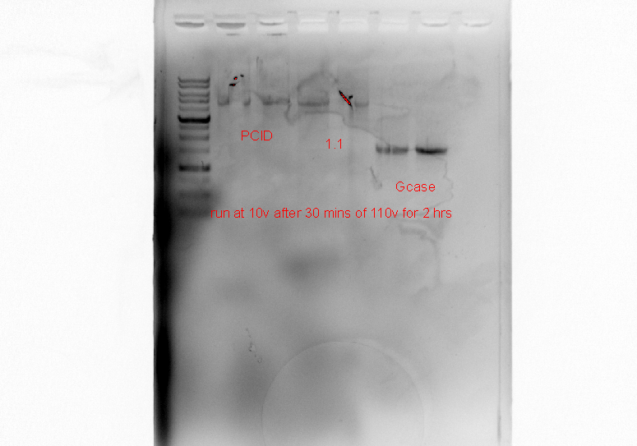

5000bp

4000bp

3000bp

2000bp

1500bp

Recombinant Plasmid

Recombinant plasmid

**Fig 4.1 Shows the bands of recombinant plasmids and glucocerebrosidase gene (Gcase) with a 1kb DNA ladder**

In fig 4.1, both pCID and 1.1 were the same vectors that went through PCR using the PIPE cloning method. The bands indicated the correct DNA band size for the recombinant plasmid of approximately 4500 bp and the Gcase gene of approximately 1500 bp.

* 1. **DNA sequencing of recombinant plasmid**
  2. **Truncated signal peptide**

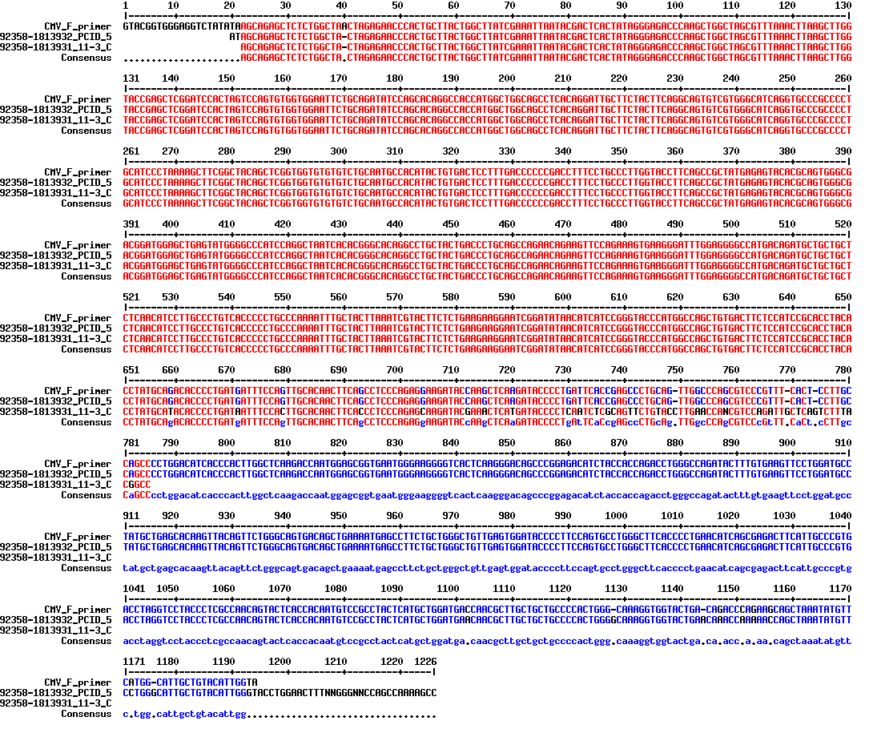

Kozak sequence

Mutations

**Fig. 4.2.1 Comparison of sequence of 2 identical clones PCID5 and 11-3 with the original sequence using CMV-F primer**

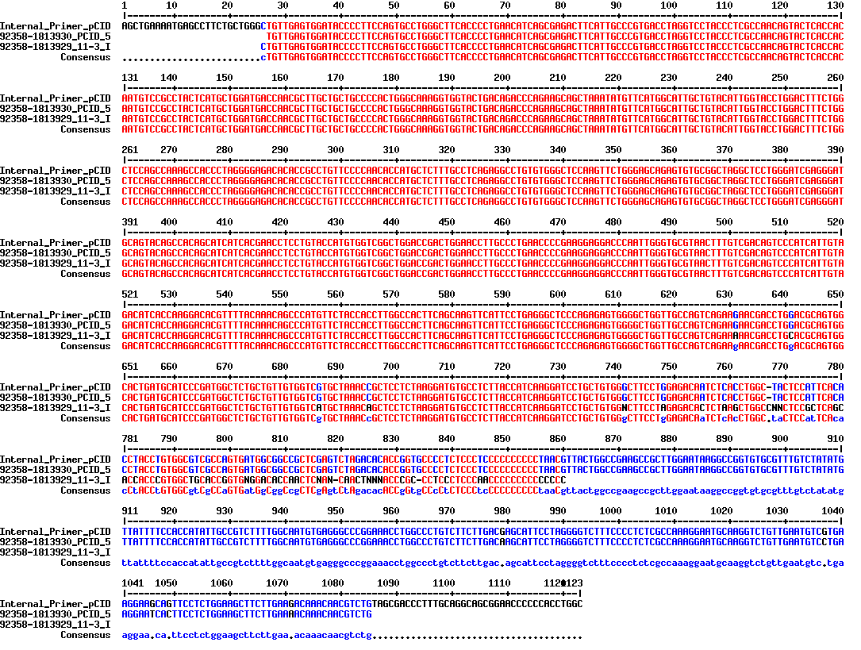

Mutations

**Fig 4.2.2 Comparison of sequence of 2 identical clones PCID5 and 11-3 with the original sequence using internal primer**

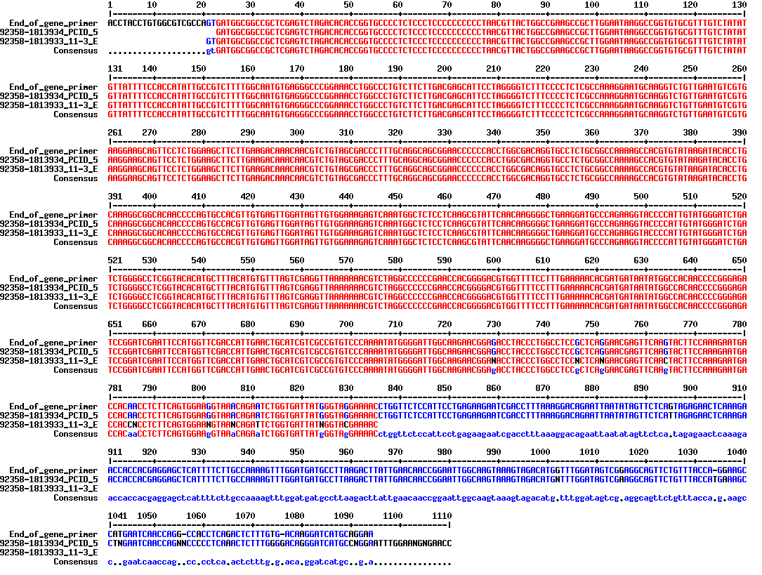

Mutation

**Fig 4.2.3 Comparison of sequence of 2 identical clones PCID5 and 11-3 with the original sequence using end of gene primer**

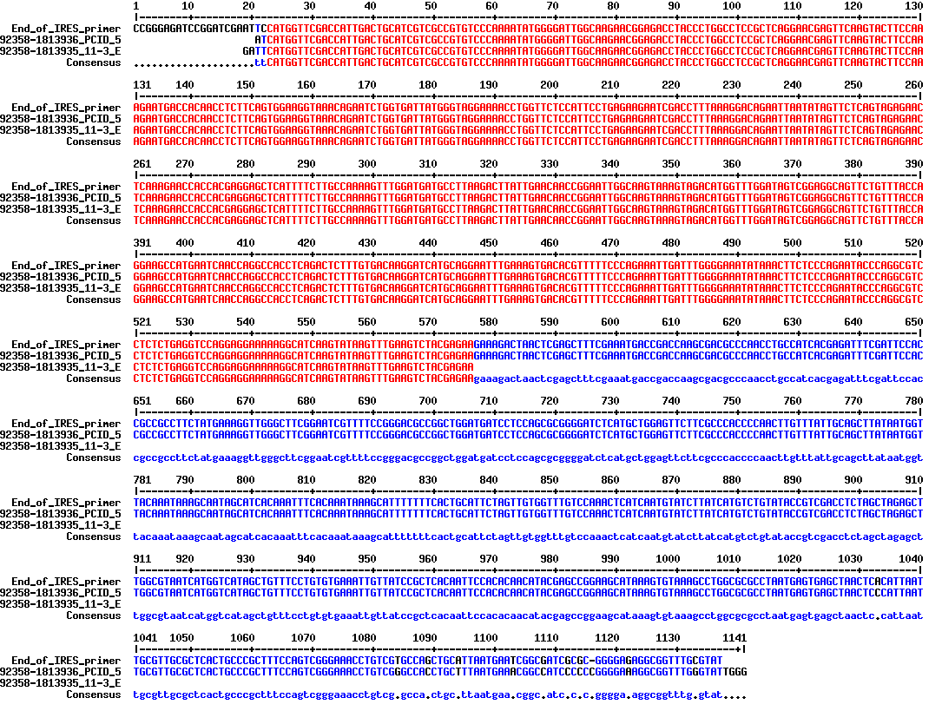

**Fig 4.2.4 Comparison of sequence of 2 identical clones PCID5 and 11-3 with the original sequence using end of IRES primer**

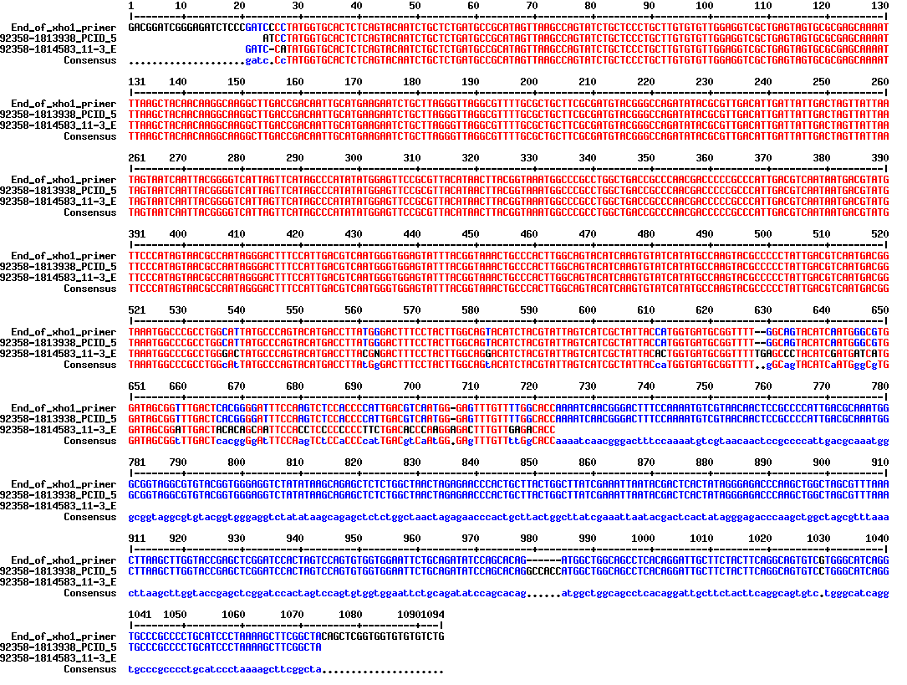

Mutations

**Fig 4.2.5 Comparison of sequence of 2 identical clones PCID5 and 11-3 with the original sequence using end of XhoI primer**

The DNA sequence shown in figures 4.2 determined that the clone PCID5 had its sequenced aligned to the original sequence compared to the clone 11-3 that had mutations in it. This also shows PIPE was successful for clone PCID5.

* 1. **Full signal peptide**

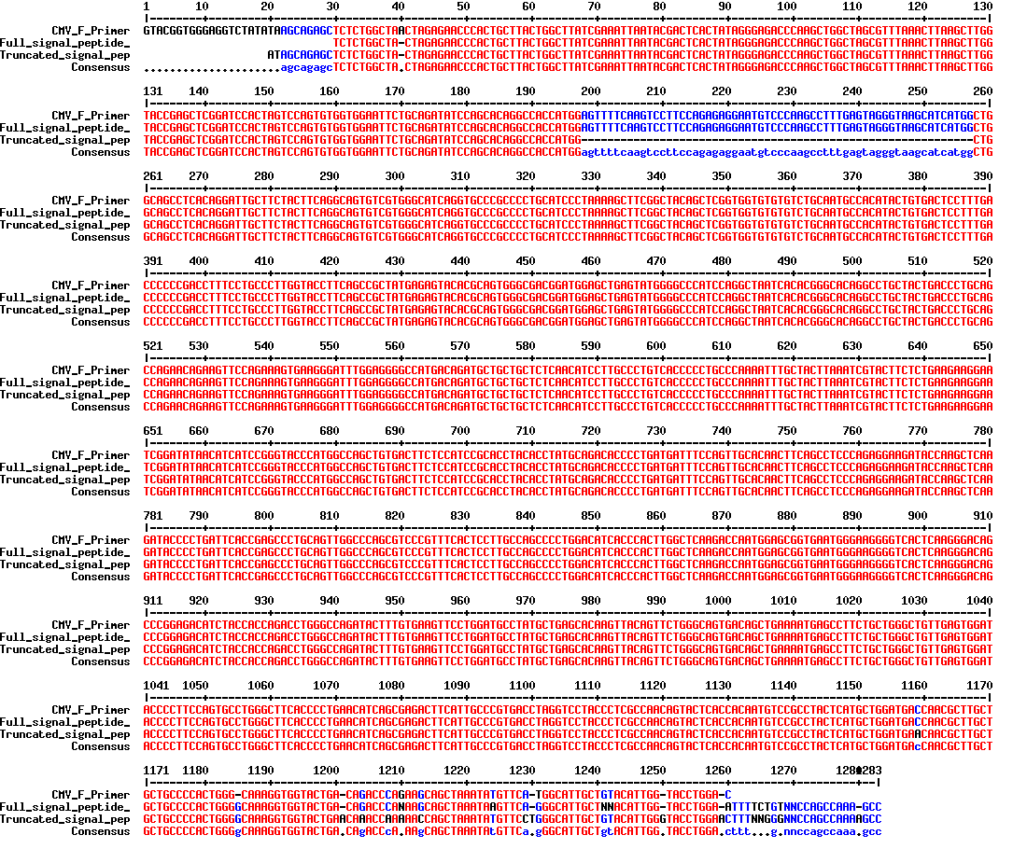**Fig 4.2.2 Comparison of sequence of 2 different clones full signal peptide and truncated signal peptide with original sequence using CMV-F primer**

Full length signal peptide

In fig 4.3, the DNA sequence showed that the full signal peptide had been fully incorporated into the plasmid using PIPE.

1. **Linearization of plasmid**

E:\Results\100516-Digest with Asc1(blank).tif

1Kb DNA ladder

Non-linearized

Linearized

Full

Truncated

Full

Truncated

**Fig 4.3 Bands of non-linearized and linearized plasmid**

In fig 4.4, the bands showed that the plasmid for both truncated and full signal peptides had been linearized using ASCI restriction enzyme.

1. **Gene amplification with methotrexate (MTX)**

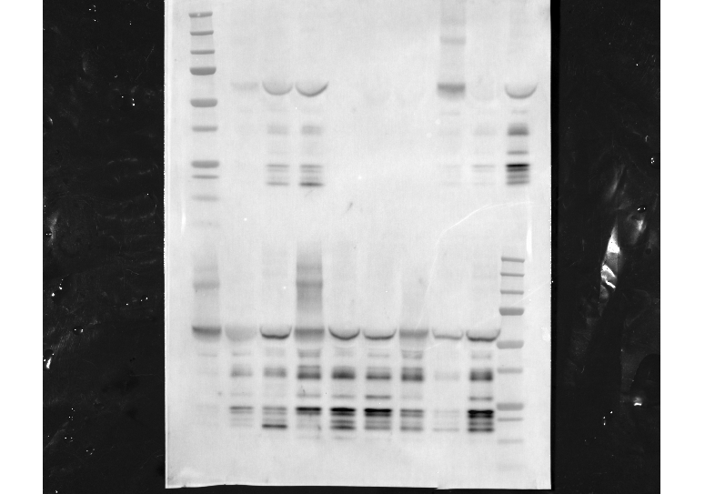

Truncated-1

Truncated-L

Full-L

50

200

500

50

200

500

50

200

500

Different phases of amplification in nM MTX



Full-1

Full-D1

Full-D2

50

200

500

50

200

500

50

200

500

25

50

75

kDa

**Fig 4.4.1 Glucocerebrosidase produced in CHO-gmt4D adherent cells**

In fig 4.4.1, the blot quantified glucocerebrosidase in their various amplification stages were indicated in the black box. 5 out of 6 pools produced glucocerebrosidase except for the Truncated-L pool that did not produce protein as seen by the lack of bands in all amplification stages. Truncated-L and Full-L are pools that had their plasmid linearized before transfection. Other bands may possibly indicate the degradation of the glucocerebrosidase protein.

Legend

**Fig 4.4.2 Graph of intensity of glucocerebrosidase bands**

In fig 4.4.2, the graph showed the intensity of bands based on the blot (refer to fig 4.4.1), with Full-1 showing the highest reading at 50 nM and 500 nM MTX amplification when compared to other pools. At 200 nM MTX amplification, Full- D1 had the highest reading.

Legend

**Fig 4.4.3 Graph of activity of glucocerebrosidase enzyme of adherent cells**

In fig 4.4.3, the graph showed that Full-D1 had the highest glucocerebrosidase enzyme activity among the rest of the pools at 500 nM MTX amplification. Full-L had the highest glucocerebrosidase enzyme activity when compared to the rest at 50 nM MTX. For 200 nM MTX amplification, it seemed that most of the pools had similar enzyme activity except for Full-L.

Legend

**Fig 4.4.4 Graph of activity of glucocerebrosidase enzyme of suspension cells**

In fig 4.4.4, the graph showed that all the pools expressed glucocerebrosidase in no HT media only.

1. **Discussion**

Overall, the study showed that amplification through increasing levels of MTX led to increase glucocerebrosidase expression level in CHO-gmt4D adherent cells. This could have been due to the increased gene copy number of DHFR in the selection pressure of MTX in which also increased glucocerebrosidase gene copy. This confirms what is stated in the literature, that using MTX to inhibit DHFR cause the cells to increase protein expression levels by increasing copy number of DHFR gene (Jayapal, Wlaschin, Hu, & Yap, 2007).

In this study, we have also shown that shortening of the glucocerebrosidase native signal peptide did not increase the expression level of the protein. This could be the incompatibility of the signal peptide on the protein. This confirms what is stated in the literature, that certain signal peptide only worked on specific protein (Dalton & Barton, 2014).

In our study, linearizing the plasmid did not show any significant increase of protein expression when compared to the non-linearized plasmid clones after going through amplification. This might be due to the chromatin positional effect. This confirms what is stated in the literature, that the site of the plasmid DNA that integrates into genome affects protein expression level (Zboray et al., 2015).

It was unexpected that all suspension pools did not express glucocerebrosidase in 50 nM MTX phase even when there was glucocerebrosidase expression during the no HT phase. This might due to the loss of the gene in the CHO cells genome or an error that occurred during the collection of the protein, low viability of the cells likely caused the protein to be extensively degraded and as such no observed activity.

This phenomenon can also be seen on Truncated-L of adherent cells.

It was also unexpected that all adherent cells that have the integrated full-signal plasmid have lower expression during the 200 nM MTX amplification. There could have been an error during the collection of the protein, the cells were not healthy which also means there were more lysed cells than healthy cells. Lysed cells release proteases that may affect protein quality (Goldman, James, Ison, & Bull, 1997).

With the use of CHO-gmt4D cells and the DHFR selection system, we have successfully attained pools of cells that highly express glucocerebrosidase. This demonstrates the utility of the widely used DHFR system and its effectiveness in producing highly expressing stable clones. However, it is a time consuming and tedious process. In the industrial setting 6 months or more might be needed for the process of selection and amplification for this system (Jayapal, Wlaschin, Hu, & Yap, 2007).

In the future, single clones can be isolated from the highest expressing pool. This is to find a clone with the highest expression. Since current results of the protein expression is just a representation of the average of all clones expressing glucocerebrosidase.

Stability test can also be conducted on the isolated single clones by removing MTX from the cell culture. So to prepare the clone for large scale industrial setting, as high expression of the protein needs to be maintained over many generations under no selection pressure.

Protein expression varies in all pools, and sometimes it does not increase with higher concentration of MTX. Hence, the results obtained from this study will contribute to future studies on gene amplification and glucocerebrosidase related studies.

1. **Conclusion**

In conclusion, the study has demonstrated that through the use of DHFR amplification and selection system we can obtain highly expressing glucocerebrosidase cell populations. The results also show that linearizing the plasmid and modifying the native signal peptide did not affect the protein expression level greatly in CHO-gmt4D cell.

However, there are more ways to optimize protein production. So, future studies should be conducted on how to overcome the chromatin positional effects as well as to test on different non-native signal peptides combination to improve protein expression levels.

**References**

1. Brumshtein, B., Wormald, M. R., Silman, I., Futerman, A. H., & Sussman, J. L. (2006). Structural comparison of differently glycosylated forms of acid-β-glucosidase, the defective enzyme in Gaucher disease. Acta Crystallographica Section D Biological Crystallography, 62(12), 1458–1465. doi:10.1107/s0907444906038303
2. Ortolano, S., Vieitez, I., Navarro, C., & Spuch, C. (2014). Treatment of Lysosomal Storage Diseases: Recent Patents and Future Strategies. Recent Patents on Endocrine, Metabolic & Immune Drug Discovery EMI, 8(1), 9-25. doi:10.2174/1872214808666140115111350
3. Nagral A. Gaucher Disease. *Journal of Clinical and Experimental Hepatology*. 2014;4(1):37-50. doi:10.1016/j.jceh.2014.02.005.
4. Brumshtein, B., Salinas, P., Peterson, B., Chan, V., Silman, I., Sussman, J. L., . . . Futerman, A. H. (2009). Characterization of gene-activated human acid- -glucosidase: Crystal structure, glycan composition, and internalization into macrophages [Introduction]. Glycobiology, 20(1), 24-32. doi:10.1093/glycob/cwp138
5. Sidransky, E., Pastores, G. M., & Mori, M. (2009). Dosing enzyme replacement therapy for Gaucher disease: Older, but are we wiser? Genetics in Medicine, 11(2), 90–91. doi:10.1097/gim.0b013e3181928f6a
6. Beutler, E. (2004). Enzyme Replacement in Gaucher Disease. PLoS Med PLoS Medicine, 1(2). doi:10.1371/journal.pmed.0010021
7. Drugs@FDA: FDA Approved Drug Products (Cerezyme). (n.d.). Retrieved from <http://www.accessdata.fda.gov/scripts/cder/drugsatfda/index.cfm?fuseaction=Search.DrugDetails>
8. Ailworth, E., & Weisman, R. (2009, June 17). Virus shuts Genzyme plant, holds up drugs for 8,000. Retrieved from:http://archive.boston.com/business/healthcare/articles/2009/06/17/genzyme_temporarily_halts_production_on_2_key_drugs/?page=1
9. Plc, Shire. (2010, February 27). Shire Announces FDA Approval Of VPRIV(TM) (velaglucerase Alfa For Injection) For The Treatment Of Type 1 Gaucher Disease. Retrieved from <http://www.medicalnewstoday.com/releases/180630.php>
10. Yeo, S. (2012, May 1). FDA approves new orphan drug to treat a form of Gaucher disease. Retrieved from http://www.fda.gov/NewsEvents/Newsroom/PressAnnouncements/ucm302549.htm
11. Jayapal, K. P., Wlaschin, K. F., Hu, W. S., & Yap, M. G. S. (2007). Recombinant protein therapeutics from CHO Cells - 20 years and counting. Chemical Engineering Progress, 103(10), 40-47.Retrived from: <http://www.aiche.org/sites/default/files/docs/pages/CHO.pdf>
12. Protein Glycosylation. (n.d.). Retrieved from <https://www.thermofisher.com/sg/en/home/life-science/protein-biology/protein-biology-learning-center/protein-biology-resource-library/pierce-protein-methods/protein-glycosylation.html>
13. Goh, J. S., Liu, Y., Chan, K. F., Wan, C., Teo, G., Zhang, P., … Song, Z. (2014). Producing recombinant therapeutic glycoproteins with enhanced sialylation using CHO-gmt4 glycosylation mutant cells. Bioengineered, 5(4), 269–273. <http://doi.org/10.4161/bioe.29490>
14. Dalton, A. C., & Barton, W. A. (2014). Over-expression of secreted proteins from mammalian cell lines. Protein Science : A Publication of the Protein Society, 23(5), 517–525. http://doi.org/10.1002/pro.2439
15. Stern, B., Olsen, L. C., Trobe, C., Ravneberg, H., & Pryme, I. F. (2007). Improving mammalian cell factories: the selection of signal peptide has a major impact on recombinant protein synthesis and secretion in mammalian cells. , 2, 1–17. Retrieved from http://www.unitargeting.com/Resources/Trends07.pdf
16. Güler-Gane, G., Kidd, S., Sridharan, S., Vaughan, T. J., Wilkinson, T. C. I., & Tigue, N. J. (2016). Overcoming the refractory expression of secreted recombinant proteins in mammalian cells through modification of the signal peptide and adjacent amino acids. PLOS ONE, 11(5), e0155340. doi:10.1371/journal.pone.0155340
17. Wang, Y., Mao, Y., Xu, X., Tao, S., & Chen, H. (2015). Codon usage in signal sequences affects protein expression and secretion using Baculovirus/insect cell expression system. PLOS ONE,10(12), e0145887. doi:10.1371/journal.pone.0145887
18. Stuchbury, G., & Münch, G. (2010). Optimizing the generation of stable neuronal cell lines via pre-transfection restriction enzyme digestion of plasmid DNA. Cytotechnology, 62(3), 189–194. http://doi.org/10.1007/s10616-010-9273-1
19. HODGES, B. (2004). Long-term Transgene expression from Plasmid DNA Gene Therapy vectors is negatively affected by CpG Dinucleotides. Molecular Therapy, 10(2), 269–278. doi:10.1016/j.ymthe.2004.04.018
20. Zboray, K., Sommeregger, W., Bogner, E., Gili, A., Sterovsky, T., Fauland, K., … Casanova, E. (2015). Heterologous protein production using euchromatin-containing expression vectors in mammalian cells. Nucleic Acids Research,43(16), e102. http://doi.org/10.1093/nar/gkv475
21. Hall, T. A. (1999). BioEdit: a user-friendly biological sequence alignment editor and analysis program for Windows 95/98/NT. Nucleic Acids Symposium Series, 41, 95–98.
22. Corpet, F. (1988). Multiple sequence alignment with hierarchical clustering.Nucleic Acids Research, 16(22), 10881–10890.
23. Goldman, M. H., James, D. C., Ison, A. P., & Bull, A. T. (1997). Monitoring proteolysis of recombinant human interferon-γ during batch culture of Chinese hamster ovary cells. Cytotechnology, 23(1-3), 103–111. <http://doi.org/10.1023/A:1007947130709>

Appendix 1

**Proposal**



**Major Project Proposal**

Development of a biobetter for Gaucher’s Disease

Name of Student : Lim Junwei Darien

Care Group : D6

Industrial Supervisor : Dr Tan Yun Lei

TP Liaison Officer : Dr Wuang Shy Chyi

Submission Date : 6/5/16

**Diploma in Chemical Engineering**

**AY 2016/2017**

Table of Contents

1 Introduction 2

2 Literature review 3

2.1 Lysosomal Storage Disease 3

2.2 Gaucher’s Disease 3

2.3 Enzyme Replacement Therapy 3

2.4 Chinese Hamster Ovary Cells 4

3 Aim of the project 4

4 Materials and Methods 5

4.1 Cell culture 5

4.2 Molecular Cloning using restriction enzymes 5

4.3 Pipe Cloning 5

4.4 Polymerase Chain Reaction(PCR) 6

4.5 Transfection 6

4.6 Selection and amplification 6

4.7 Western Blot 7

4.8 Enzyme Activity Assay 7

5 Time Schedule 8

6 References 9

### 1 Introduction

Gaucher’s Disease is a type of Lysosomal Storage Disease (LSD) that affects lysosomal function. It is an inherited metabolic disease resulting in multi-systemic symptom, affecting 1 in 57 000 people in the general population. In this project, we will be aiding in Enzyme Replacement Therapy (ERT) for Gaucher’s Disease (1). Patients suffering from Gaucher’s Disease inherit a mutated form of the enzyme glucocerebrosidase. Therefore, they require frequent infusions of the recombinant wild type enzyme to maintain normal lysosomal function, restoring patients’ health. Recombinant glucocerebrosidase is taken up through mannose receptors on affected macrophage cells. As such, mannose-terminated glycans on recombinant glucocerebrosidase is necessary for efficient uptake into macrophages. (1) We propose to express glucocerebrosidase in Chinese Hamster Ovary (CHO) cells that have a modified glycosylation process allowing the production of predominantly mannose-terminated glycans in a single step. In the current market, imiglucerase or Cerezyme® is the only protein drug that is expressed in wild type CHO cells, which requires a second step to modify the heterogeneous glycan population of glucocerebrosidase to predominantly mannose-terminated forms. (2) The other biosimilars are expressed in carrot cells (taliglucerase alfa) and human cells (velaglucerase alfa) (1). The current problem is that these protein drugs are extremely expensive, costing approximately US$200,000 per year. (3) This project aims to produce a biobetter that has greater efficacy and functionality over the existing drugs, while reducing cost to patients.

### 2 Literature review

### 2.1 Lysosomal Storage Diseases

LSDs are caused by specific mutations in genes encoding lysosomal enzymes, which in turn prevent the degradation of their specific substrates, which include a wide variety of glycolipids, oligosaccharides and glycoproteins. There are more than 50 distinct lysosomal storage diseases, with most being inheritable autosomal recessive diseases. (1)

### 2.2 Gaucher’s Disease

Gaucher’s Disease is characterised by the accumulation of the glycolipid substrate glucosylceramide in lysosomes of macrophage cells. There are three types of Gaucher’s Disease, with type I being the most common in patients. Some of the symptoms include enlarged liver and/or spleen, low blood platelet count, anaemia and low white blood cell count. Patients with type II and III Gaucher’s Disease also suffer extensive neurological symptoms, and often do not survive past early adulthood. At present, only type I Gaucher’s Disease can be treated by Enzyme Replacement Therapy. (4)

### 2.3 Enzyme Replacement Therapy

ERT is the replacement of a mutated lysosomal enzyme by a recombinant wild type enzyme that will be taken into macrophages intravenously. Glucocerebrosidase is taken in through mannose receptors on macrophage cells. As such, the glycans on recombinant glucocerebrosidase have to be mannose-terminated for efficient uptake. (1)

The first drug approved by the United States Food and Drug Adminstration (FDA) for Gaucher’s Disease was Cerezyme® in 1994(5). Cerezyme® is expressed in wild type CHO cells, producing a heterogeneous population of glycans on the recombinant enzyme. A second step is required to modify the glycans on glucocerebrosidase to predominantly mannose-terminated forms. (2) In 2009, there was a virus contamination in the Cerezyme® manufacturing plant and it greatly affected the overall drug supply for Gaucher’s Disease. This incident catalysed the FDA approval of biosimilars velaglucerase alfa in 2010(6) and taliglucerase alfa in 2012. (7) Since Gaucher’s Disease is a rare disease, the treatment can cost up to US$200 000 annually (3).

### 2.4 Chinese Hamster Ovary Cells

CHO cells are excellent for the expression of proteins and they are most commonly used for the mass production of recombinant protein products due to their capacity for single cell suspension culture. They can be genetically modified as well, for example, the knockout of genes can be performed with relative ease. (8) Furthermore, proteins produced in CHO cells have similar properties and post-translational modifications compared to that of native human proteins, which greatly decreases the likelihood of rejection when administered to patients. Thus, CHO cell lines are important in bioprocessing research and the manufacturing of therapeutic biopharmaceuticals by increasing protein productivity and reducing safety concerns. (9)

Glycosylation, the process of attaching sugar moieties to proteins, is a post-translational modification that provides great proteomic diversity. Glycosylation is important for many biological processes which includes cell attachment to the extracellular matrix and protein-ligand interactions in the cell endogenously. (10) Glycosylation of recombinant protein drugs may also enhance drug efficacy and longevity. (9) In particular, modification of glycans on recombinant glucocerebrosidase is vital for its uptake into macrophages through the mannose receptors. CHO-gmt4, developed by the Song lab, is a mutant that has lost the gene *N*-acetylglucosaminyltransferase I (GnT1). This cell line was selected using Ricinus communis agglutinin-1 (RCA1) treatment. This mutant produces protein with mannose-terminated N-glycans, allowing us to bypass the second enzymatic deglycosylation step required in the production of Cerezyme. CHO-gmt4D is a mutant that has lost GnT1 and the dihydrofolate reductase (DHFR) gene. DHFR was knocked out by the Song lab using a zinc finger nuclease, allowing us to select for and amplify the expression of glucocerebrosidase. In this project, we will utilise the CHO-gmt4D cell line for the production of recombinant glucocerebrosidase. (11)

### 3 Aim of the project

The aim of the project is to produce a glucocerebrosidase biobetter, that has greater efficacy and functionality over the existing protein drugs in the market, while lowering the cost to patients. Molecular cloning will be performed to construct a plasmid encoding for glucocerebrosidase and DHFR. Next, a series of transfection, selection and amplification of these genes in CHO-gmt4D cells will be conducted to get the most desirable result. The objective is to obtain cells that have very high levels of glucocerebrosidase expression to fulfil the market needs.

### 4 Materials and Methods

### 4.1 Cell culture

The CHO-gmt4D glycosylation mutant cells used in this project was provided by Dr Tan Yun Lei. It produces glycoproteins with predominantly mannose-terminated N-glycans.Recombinant glucocerebrosidase produced in this line should have mannose-terminated N-glycans that will enhance its uptake into macrophages through the mannose receptors. Adherent CHO-gmt4D cells were cultured in Dulbecco’s modified eagle media (DMEM) + Glutamax™ (Life Technologies) with 10% fetal bovine serum (FBS) and Hypoxanthine-Thymidine (HT) supplement (Life Technologies). Adherent cells were grown at 37°C in a humidified incubator with 5% CO2. Suspension CHO-gmt4D cells were cultured in a 1:1 mixture of HyClone™ (GE,USA) and CD-CHO (Life Technologies) media supplemented with HT, 6 mM L-glutamine and 0.05% pluronic acid. Cells were grown at 37°C and 115rpm in a humidified incubator with 8% CO2.

### 4.2 Molecular Cloning using restriction enzymes

The isolation of a DNA sequence (usually a gene) to be inserted into a vector suitable for transfection into mammalian cells. The pCID vector and the glucocerebrosidase gene were provided by Dr Tan Yun Lei. The gene amplicon was obtained using Polymerase Chain Reaction (PCR) through the use of Pfx DNA polymerase from Invitrogen, USA. Both pCID vector and glucocerebrosidase gene sequence were digested using Nhe1 and Not1 restriction enzymes from New England Biolabs, USA. The ligation of the pCID vector and the gene was done using T4 Ligase from New England Biolabs, USA. The resulting plasmid was transformed using One Shot TOP10™ bacterial cells from Invitrogen, USA. These cells were cultured on agar plates that consist of ampicillin to select for colonies that had the plasmid encoding the ampicillin-resistant gene.

### 4.3 Polymerase Incomplete Primer Extension (PIPE) Cloning

Another method of molecular cloning without the use of restriction enzymes. This method takes advantage of the fact that PCR generates DNA molecules that are incompletely extended during the last few cycles. This results in overhangs for each PCR product, allowing intermolecular complementation when mixed together, bypassing the use of a ligase.Primers were designed according to the selected sequence in the pCID vector and glucocerebrosidase gene. Both DNA templates will go through PCR using Pfu Turbo DNA polymerase (Agilent,USA). Subsequently, both pCID vector and the gene were digested with Dpn1 from Agilent Technologies,USA to remove methylated DNA. Digested pCID vector and glucocerebrosidase gene sequence was mixed to get the recombinant plasmid. The recombinant plasmid was transformed using One Shot TOP10™ bacterial cells from Invitrogen,USA. These cells were cultured on agar plates that consist of ampicillin to select for colonies that had the plasmid encoding the ampicillin-resistant gene.

**4.4 Polymerase Chain Reaction (PCR)**

To make multiple copies of selected DNA in a PCR machine.The DNA was denatured over 90°C and the primers will anneal to the single stranded DNA under the condition of 40°C to 60°C. The temperature was increased to 72°C for the DNA polymerase to extend and replicate the DNA strand. This cycle repeats 30 to 35 times, exponentially generating the desired product.

### 4.5 Transfection

Is the introduction of foreign DNA into cells, preferably to be inserted into the genome.

CHO-gmt4D cell line that has dysfunctional GnT-I and DHFR genes wil be used

Electroporation will be used to insert the recombinant plasmid into the CHO-gmt4D cells. Cell culture plates will be prepared. Desired density of cells will be measured using a cell counter and prepared for centrifugation. The cell pellet will be resuspended in room temperature 4D Nucleofector™ Solution (Lonza, USA). Recombinant plasmid encoding glucocerebrosidase and DHFR will be added to the solution. Subsequently, the solution will be transferred into the Nucleocuvette™ Vessels. The vessel will be placed into the retainer of 4D-Nucleofector™ Core unit (Lonza, USA) and run with the selected protocol on the machine. The cells will be grown in a humidified incubator at 37°C in the culture medium until further analysis.

### 4.6 Selection and amplification

DHFR is used as our genetic selection marker since our cell line CHO-gmt4D lacks DHFR activity. Transfected CHO-gmt4D cells will be cultured in normal culture medium. After recovery, culture medium will be changed to one that does not contain HT supplement to facilitate the selection of cells that have incorporated the recombinant plasmid. Multiple rounds of amplification using increasing concentration of methotrexate will allow us to select for cells that produce the highest levels of recombinant protein.

### 4.7 Western Blot

This is used for protein identification and analysis through the interaction of antibody and antigen.

The mixture of proteins in conditioned medium is separated on a Sodium Dodecyl Sulfate Polyacrylamide Gel Electrophoresis (SDS-PAGE) gel. Next, the proteins will be transferred from the gel to a polyvinylidene difluoride (PVDF) membrane. Blocking of the membrane will be done using non-fat milk to prevent non-specific binding. After blocking, the membrane will be incubated with the primary rabbit polyclonal anti-glucocerebrosidase antibody (Sigma,USA). After washing, the membrane is incubated with an anti-rabbit secondary antibody conjugated to horseradish peroxidase (HRP). After washing, the membrane is then incubated with an HRP substrate. Chemiluminescence produced by the cleavage of the HRP substrate will be detected on an imager.

### 4.8 Enzyme Activity Assay

Is the measure of enzyme activity by using a modified glucocerebrosidase substrate that when hydrolysed by the enzyme, releases a fluorescent molecule. By quantifying the fluorescence given off, we can quantify the concentration of glucocerebrosidase present in conditioned media.4-Methylumbelliferyl β-D-glucopyranoside (MUG) from Sigma in an acetate buffer, pH 4 will be added to each well containing conditioned media in a 96-well plate. The plate will be incubated at 37°C for an hour and the reaction will be quenched by the addition of a high pH glycine buffer to each well. The fluorescence of the liberated 4-methylumbelliferone will be measured (excitation 365nm and emission 445nm) using a fluorescence plate reader.

**5 Time Schedule**

**6 References**

1. Ortolano, S., Vieitez, I., Navarro, C., & Spuch, C. (2014). Treatment of Lysosomal Storage Diseases: Recent Patents and Future Strategies. Recent Patents on Endocrine, Metabolic & Immune Drug Discovery EMI, 8(1), 9-25. doi:10.2174/1872214808666140115111350
2. Brumshtein, B., Salinas, P., Peterson, B., Chan, V., Silman, I., Sussman, J. L., . . . Futerman, A. H. (2009). Characterization of gene-activated human acid- -glucosidase: Crystal structure, glycan composition, and internalization into macrophages [Introduction]. *Glycobiology,* *20*(1), 24-32. doi:10.1093/glycob/cwp138
3. Ailworth, E., & Weisman, R. (2009, June 17). Virus shuts Genzyme plant, holds up drugs for 8,000. Retrieved from:http://archive.boston.com/business/healthcare/articles/2009/06/17/genzyme_temporarily_halts_production_on_2_key_drugs/?page=1
4. Beutler, E. (2004). Enzyme Replacement in Gaucher Disease. PLoS Med PLoS Medicine, 1(2). doi:10.1371/journal.pmed.0010021
5. Drugs@FDA: FDA Approved Drug Products (Cerezyme). (n.d.). Retrieved from <http://www.accessdata.fda.gov/scripts/cder/drugsatfda/index.cfm?fuseaction=Search.DrugDetails>
6. Plc, Shire. (2010, February 27). Shire Announces FDA Approval Of VPRIV(TM) (velaglucerase Alfa For Injection) For The Treatment Of Type 1 Gaucher Disease. Retrieved from <http://www.medicalnewstoday.com/releases/180630.php>
7. Yeo, S. (2012, May 1). FDA approves new orphan drug to treat a form of Gaucher disease. Retrieved from http://www.fda.gov/NewsEvents/Newsroom/PressAnnouncements/ucm302549.htm
8. Xu, X., Nagarajan, H., Lewis, N. E., Pan, S., Cai, Z., Liu, X., … Wang, J. (2011). The Genomic Sequence of the Chinese Hamster Ovary (CHO) K1 cell line. *Nature Biotechnology*, *29*(8), 735–741.(Abstract) <http://doi.org/10.1038/nbt.1932>
9. Jayapal, K. P., Wlaschin, K. F., Hu, W. S., & Yap, M. G. S. (2007). Recombinant protein therapeutics from CHO Cells - 20 years and counting. Chemical Engineering Progress, 103(10), 40-47.Retrived from: <http://www.aiche.org/sites/default/files/docs/pages/CHO.pdf>
10. Protein Glycosylation. (n.d.). Retrieved from https://www.thermofisher.com/sg/en/home/life-science/protein-biology/protein-biology-learning-center/protein-biology-resource-library/pierce-protein-methods/protein-glycosylation.html
11. Goh, J. S., Liu, Y., Chan, K. F., Wan, C., Teo, G., Zhang, P., … Song, Z. (2014). Producing recombinant therapeutic glycoproteins with enhanced sialylation using CHO-gmt4 glycosylation mutant cells. *Bioengineered*, *5*(4), 269–273. <http://doi.org/10.4161/bioe.29490>

Appendix 2

**Enzyme Activity Assay after 50nM amplification of adherent cells**

Bottom Reading

|  |  |
| --- | --- |
| Concentration(µM) | Absorbance |
| 100 | 29708 |
| 75 | 23828 |
| 50 | 16481.5 |
| 25 | 9259 |
| 12.5 | 4860 |
| 5 | 2034.5 |
| 2.5 | 1060 |
| 1 | 457 |

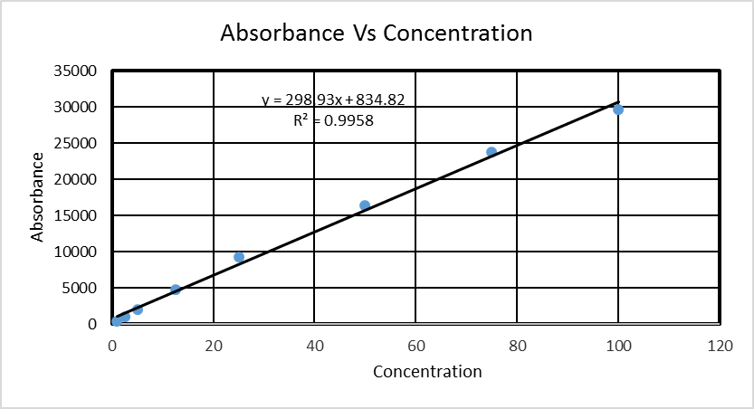

Top Reading

|  |  |
| --- | --- |
| Concentration(µM) | Absorbance |
| 100 | 27534.5 |
| 75 | 22110.5 |
| 50 | 15043 |
| 25 | 8690.5 |
| 12.5 | 4545.5 |
| 5 | 1847 |
| 2.5 | 961.5 |
| 1 | 407.5 |

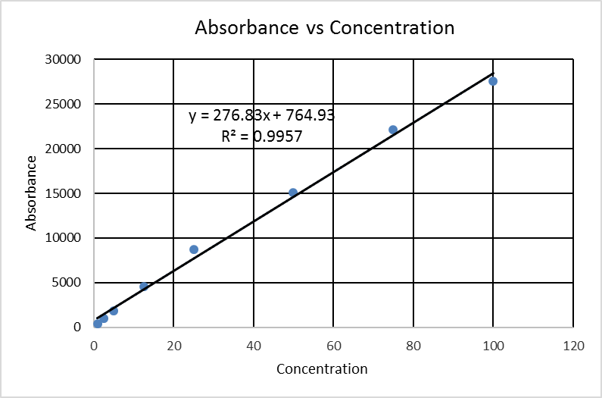





Bottom Reading

Bottom Reading

|  |  |
| --- | --- |
| Concentration | Absorbance |
| 75 | 22127 |
| 50 | 15441 |
| 25 | 8352 |
| 12.5 | 4427 |
| 5 | 1883 |
| 2.5 | 827.5 |
| 1 | 409.5 |

Top Reading

|  |  |
| --- | --- |
| Concentration | Absorbance |
| 75 | 23489.5 |
| 50 | 16216 |
| 25 | 8669 |
| 12.5 | 4591.5 |
| 5 | 1942 |
| 2.5 | 842 |
| 1 | 413 |

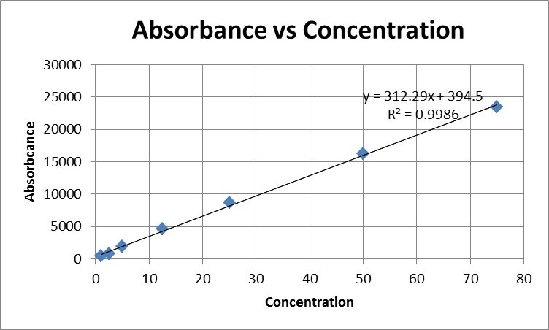





Appendix 3

Bottom Reading

**Enzyme Activity Assay after 200nM amplification of adherent cells**

Bottom Reading

|  |  |
| --- | --- |
| Concentration | Absorbance |
| 100 | 28058 |
| 75 | 22030 |
| 50 | 15823.5 |
| 25 | 8778 |
| 12.5 | 4528.5 |
| 5 | 1781.5 |
| 2.5 | 919.5 |
| 1 | 423 |

|  |  |
| --- | --- |
| Concentration | Absorbance |
| 100 | 25084 |
| 75 | 19823.5 |
| 50 | 14351.5 |
| 25 | 7955.5 |
| 12.5 | 4137 |
| 5 | 1649 |
| 2.5 | 878.5 |
| 1 | 375 |

Top Reading





Appendix 4

**Enzyme Activity Assay after 500nM amplification of adherent cells with different collection dat**es

Bottom Reading

|  |  |
| --- | --- |
| Concentration | absorbance |
| 100 | 43944.5 |
| 75 | 29270.5 |
| 50 | 19732.5 |
| 25 | 10234.5 |
| 12.5 | 5448 |
| 5 | 2103 |
| 2.5 | 1172 |



Top Reading

|  |  |
| --- | --- |
| Concentration | absorbance |
| 100 | 43779.5 |
| 75 | 29452.5 |
| 50 | 19584 |
| 25 | 10419.5 |
| 12.5 | 5448 |
| 5 | 2144 |
| 2.5 | 1180.5 |

Appendix 5

**Enzyme Activity Assay after recovery from no HT media for suspension cells**

Bottom Reading

Top Reading

|  |  |
| --- | --- |
| Concentration | Absorbance |
| 75 | 22127 |
| 50 | 15441 |
| 25 | 8352 |
| 12.5 | 4427 |
| 5 | 1883 |
| 2.5 | 827.5 |
| 1 | 409.5 |

|  |  |
| --- | --- |
| Concentration | Absorbance |
| 75 | 23489.5 |
| 50 | 16216 |
| 25 | 8669 |
| 12.5 | 4591.5 |
| 5 | 1942 |
| 2.5 | 842 |
| 1 | 413 |







Appendix 6

**Enzyme Activity Assay after 50nM amplification for suspension cells**

Bottom Reading

|  |  |
| --- | --- |
| Concentration(µM) | absorbance |
| 100 | 42277.5 |
| 75 | 33523 |
| 50 | 23030.5 |
| 25 | 12978 |
| 12.5 | 6920 |
| 5 | 2645 |
| 2.5 | 1410.5 |

Top Reading

|  |  |
| --- | --- |
| Concentration(µM) | absorbance |
| 100 | 40983.5 |
| 75 | 32806 |
| 50 | 22981.5 |
| 25 | 13131 |
| 12.5 | 6937 |
| 5 | 2644.5 |
| 2.5 | 1419.5 |



